BRANCH NEWS JANUARY 2021
Registered charity No. 106918

NEW YEAR GREETINGS

I think many of us have struggled with the incongruity of using words like “merry” and “happy” in the current circumstances. However on behalf of the Branch Committee I would like to wish everyone a better year in 2021 than we have had during the grim days of 2020. No-one needs to be reminded of the global suffering caused by the pandemic. Many of our members have had their own personal sorrows, some related to Covid-19, some not. And we still have challenging winter months ahead of us.
But, as we know, there is a glimpse of light at the end of the dark tunnel we’re currently in. And this brings huge hope that we may be able to dance again, at least by the time 2021 is out. Perhaps in time for a full new season of dancing from September on? Maybe even a limited programme in the late spring or summer of the coming year….?
In the meantime, the RSCDS has worked tirelessly to try to keep our spirits up through virtual events, on-line classes, podcasts, information and entertainment. It was good to see that some of those who have been responsible for these delights were honoured by the Society at the virtual AGM in November.
Prospects of a possible return to Scottish Country Dancing in 2021 have led some of us to speculate on whether we’ll actually be able to dance again when the time comes! Will we remember any dances? What will our footwork be like? Do we still have those muscles in our bodies? One of our local dancers and I shared a laugh as we exchanged tales of hauling ourselves upstairs by the bannisters rather than tripping the light fantastic across the dance-floor.
However – will any of that matter just so long as we can re-establish the warmth and camaraderie that we all enjoy so much? After all, fun and friendship are what we value – and maybe the fitness will come along in due course again too!

So – best wishes for a much happier new year to you all!

Our Branch Committee would also like members to know that we have been continuing to meet occasionally over the past year. Our February 2020 committee meeting had to be cancelled because of the weather, our March meeting because of Covid and the imminent lockdown, and all our meetings since then have been by Zoom. We’re meeting again on Saturday 9 January 2021 to share thoughts about the prospects for the year ahead. If you would like to share any reflections, or even just tell us how you’re doing, that would be lovely. Contact details are at the end of this Newsletter.
In the meantime, here’s an article that will no doubt interest you. Earlier in 2020 one of our longstanding members, Johan Cleaver from Cwmbrân, provided an article for The Reel”, the London Branch publication. She has kindly agreed to let me re-print it here. Thank you, Johan. What great memories.

Memories of the Teachers’ Certificate Class in the 1960s

The LCC Institute in Gough Square, off Fleet Street, was the place of our hard endeavours to become the Society’s budding Scottish country dance teachers.
Our stalwart tutor was Frances Stamp, such a patient, knowledgeable and kind lady who possessed a great air of calmness and serenity, but who had an all-seeing eye which spotted every misdemeanour.

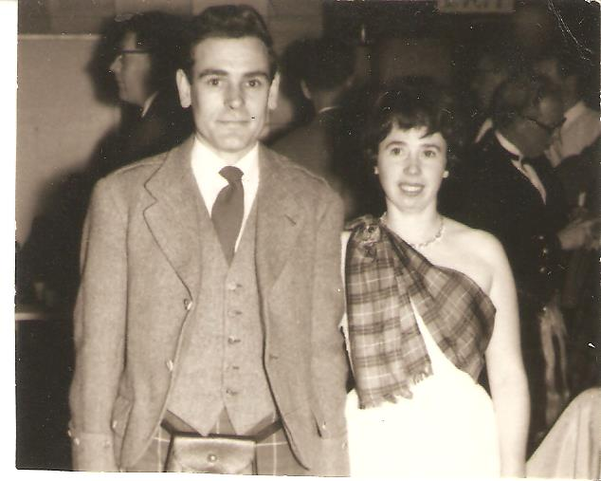
Jim and Johan Cleaver
Photo courtesy of Johan

In stark contrast to my own nerves, which were jangling as I tried my best to remember all the salient points of technique, foot positions, phrasing, hand-giving, honouring one’s partner, and to keep smiling, whilst dancing! Then to consider how one was going to impart this to others so that they could enjoy the fun, exhilaration and social well-being that Scottish country dancing engenders.
I had the great privilege of being part of the class which saw the embryonic stage in the careers of such well-known and brilliant teachers as Helen Brown, Owen and Christine Meyer, John Laurie and many more. Phyllis Draper was our main pianist, and her accomplished playing inspired us to interpret the essence of the dances.
I will always treasure the camaraderie of the class. Come Saturday 6 April 1968 we were all anticipating our examinations, but firstly there was the Branch Day School which Miss Jean Milligan held. It was well attended by Society members, as they were keen to learn from our Founder. They also gave us great support on our examination day, when we had to teach a dance that had been newly selected for each of us. Strange how some candidates suddenly developed amnesia. All done with good humour – they were not going to let us off lightly! My feeling of elation knew no bounds when Jean Milligan indicated that I had passed!
Johan Cleaver (née McKail)

CONTACT US
Conor Farmer 07812 569744
conorfarmer52@googlemail.com
Alison Jackson 07811 082510
jacksonaj@talktalk.net
Pat Rye 01646 698463
ryedp@hotmail.com

